42.4: The energy of the emitted photon is 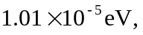 and so its frequency and wavelength are
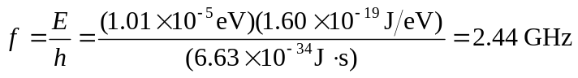
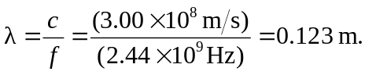
This frequency corresponds to that given for a microwave oven.

